Tuple
- A tuple is created by placing all the items (elements) inside parenthesis ( ), separated by commas.
- The parenthesis are optional, however, it is good practice to use them.
- A tuple can have any number of items (elements) and they may be of different types (integer, float, string, etc.).
- example
  - T = (1,2,3,4)
  - T = ('hari','mohan','james')
  - T = ('hari','mohan',20,30,40)
- creating Empty tuple:
  - T = ( )
- Creating tuple without using parenthesis:
- T = 1,2,3,'ram'
- This is known as tuple packing
- Creating tuple with one element:
- placing element inside parenthesis is not sufficient. We need to provide single comma after element.
- T = ( 5, )

Python Create Tuple

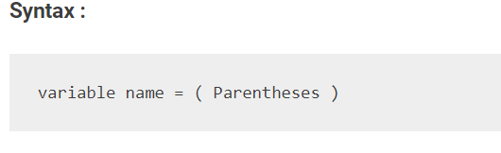

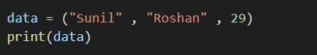

OUTPUT

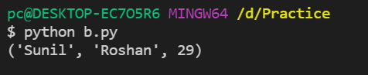

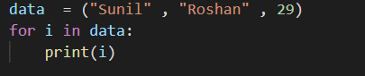

OUTPUT

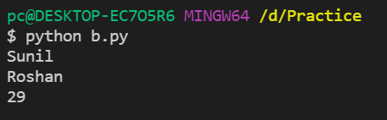

python tuple slicing & Indexing

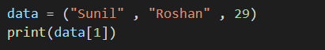

OUTPUT

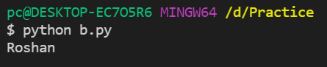

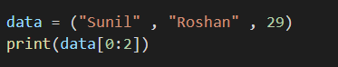

OUTPUT

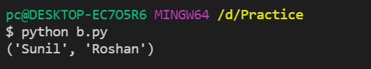

Creating Tuple Using Range () Function

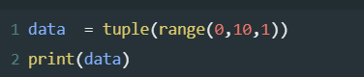

OUTPUT

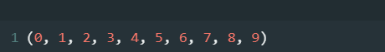

Python tuple Len()

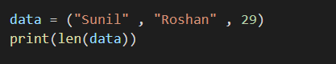

OUTPUT

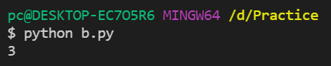

Tuple with one element

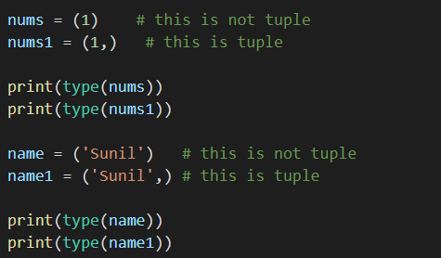

OUTPUT

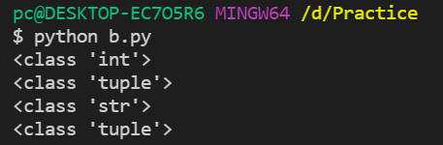

Python list inside tuple
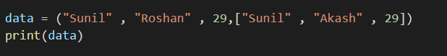
OUTPUT

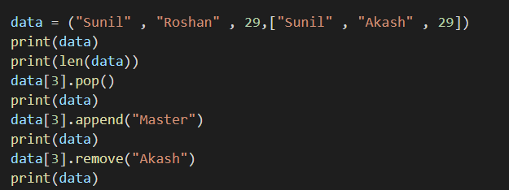
OUTPUT
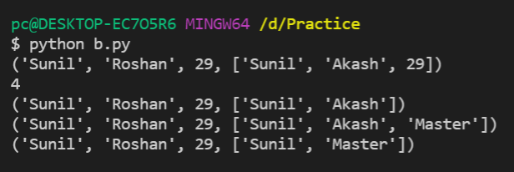

Python min & max Function
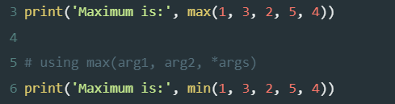
OUTPUT
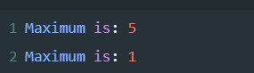

Concatenation of two tuple
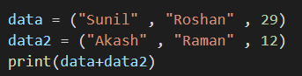
OUTPUT
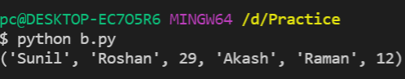
Question: Write a Python program to add an item in a tuple.
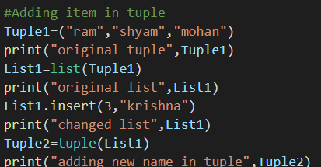
OUTPUT
